An LLM-RAG Based Text-Media Anti-Fraud Recognition System with Training-Question Generation for College Students
System report with risk-aware hybrid evidence fusion, reranking, and preliminary runtime evidence
Course Name: Neural Network & Deep Learning
Student Name: Han Yihe
Student ID: 202329013035N

Abstract
This report presents a Chinese-English bilingual and mixed-language LLM-RAG prototype for text-media anti-fraud recognition with training-question generation. It accepts SMS, email, chat, OCR screenshot text, URL descriptions, and social posts, then returns risk level, fraud type, risk features, retrieved evidence, advice, compliance_rewrite, training_question, and JSON. The prototype combines feature extraction, BM25, BGE-M3 with FAISS, URL/domain matching, evidence fusion, BGE reranking, and Qwen reasoning [1, 2, 3, 4, 5]. Runtime evidence covers the Streamlit interface, CLI mock output, index manifest, and tests.

1. Introduction

1.1 Background
College students use SMS, instant messaging, social platforms, email, and campus portals that can be abused by fraudsters impersonating university offices, recruiters, banks, customer service staff, or classmates. Smishing research shows that users may struggle to distinguish real from fraudulent SMS messages [6]. Common risks include part-time job scams, refund phishing, scholarship fraud, campus-loan threats, game-account trading fraud, malicious links, and mailbox credential theft. Because these attacks are short text-media messages, the system must handle bilingual wording, URLs, urgency cues, payment requests, and impersonation together.

1.2 Motivation
Traditional keyword rules are transparent but brittle: small wording changes can evade exact matches. URL blacklists help, but they miss new domains and messages that only describe malicious actions. Conventional classifiers may label risk without explaining supporting evidence. Retrieval-augmented generation is useful because retrieved evidence makes generation more specific, updateable, and inspectable [3]. For campus education, students also need reasons, safe response advice, and quiz-style questions.

1.3 Project Objective
The project has five goals: detect fraud risk, classify fraud type, extract explicit risk features, retrieve anti-fraud evidence, and generate student-facing advice with quiz-style questions. It is therefore a recognition system with training-question generation, not a full adaptive learning platform. It exposes stable JSON fields such as risk_features, risk_level, risk_score, fraud_type, evidence_fusion, compliance_rewrite, training_question, and evaluation_labels.

2. System Requirements and Data Sources

2.1 System Requirements
The system is designed for text-based media content rather than a single document type. It supports Chinese, English, and mixed-language fraud content from SMS, chat messages, OCR-extracted screenshots, URL descriptions, email bodies, and social-media posts. The Streamlit interface provides text input, screenshot upload, example selection, a mock-mode toggle, and a top-k retrieval slider, keeping the prototype usable without an API key.

2.2 Output Requirements
The required output serves recognition and learning support by reporting risk level, fraud type, triggering features, retrieved evidence, fusion scores, concise advice, safe rewrite, and quiz question. Table 1 lists these fields. Here, compliance_rewrite means transforming risky or fraudulent content into a safe educational warning or response template; it must not make the original message more persuasive.

Table 1. Required output fields and functions.
Output field | Function
risk_level / risk_score | Summarize the severity of the detected risk.
fraud_type | Name the likely scam pattern, such as phishing or upfront-fee fraud.
risk_features | Expose URLs, domains, payment requests, urgency cues, and credential requests.
evidence_fusion | Record retrieval scores and ranking components for inspection.
training_question | Convert the detection result into an educational exercise.
evaluation_labels | Support later automatic checks and ablation analysis.

2.3 Data Sources
The index builder loads campus Chinese-English rules [7], ChiFraud cases [8], SMS/MMS examples [9], Discord scam messages [10], email safety triage data [11], phishing-domain lists [12, 13], and scam-domain blacklists [14]. The persisted index contains 4,850 knowledge items, 659,034 domains, and 198,017 URLs: 50 campus rules plus 1,200 items each from ChiFraud, SMS/MMS, Discord, and email sources.
These sources differ in labels, language coverage, collection dates, and benign/malicious ratios. Formal evaluation should hold out test cases, remove near-duplicates by normalized fingerprints, and report IOC-blacklist hits separately from non-IOC cases, since exact matches test indicator lookup while non-IOC cases test semantic generalization.

3. Architecture and Core Principle

3.1 Overall System Architecture
The system follows a retrieval-augmented pipeline from raw text-media input to structured safety output, consistent with RAG's separation of model reasoning and evidence retrieval [3]. Figure 1 illustrates the pipeline. After normalization and language detection, an extractor identifies risk features; the same input is searched through lexical retrieval, dense vector retrieval, and exact IOC matching. Candidate evidence is fused, reranked, and injected into a Qwen prompt, then normalized into a stable JSON schema for the Streamlit interface, CLI demo, and evaluation scripts.
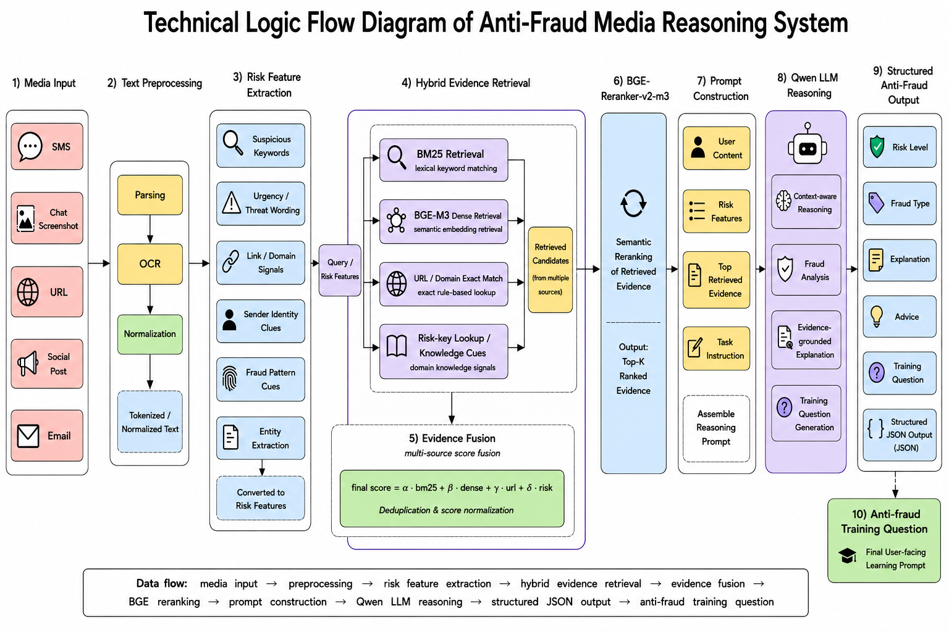
Figure 1. Technical logic flow of the risk-aware hybrid RAG anti-fraud system.

3.2 Core Mechanism: Risk-aware Hybrid Evidence Fusion and Reranking

3.2.1 Risk Feature Extraction
The core mechanism is risk-aware hybrid evidence fusion and reranking. Fraud text often mixes explicit scam words, semantic variants, suspicious links, urgency, payment requests, credential requests, and impersonation. The risk-feature module extracts URLs, domains, phone numbers, money mentions, and weighted category hits such as credential_request, financial_info, upfront_payment, urgency_pressure, impersonation, campus_context, refund_or_reward, job_or_internship, and investment_or_loan. These independent signals improve interpretability before the LLM is called.

3.2.2 Hybrid Candidate Retrieval
Hybrid retrieval broadens recall. BM25 captures exact lexical evidence such as verification code, bank card, refund, deposit, campus loan, or mailbox suspension [5]. BGE-M3 dense embeddings with FAISS capture semantic similarity across Chinese, English, and mixed-language variants [1, 2]. Exact URL/domain matching adds high-confidence indicator evidence, and risk-keyword alignment raises evidence whose categories match extracted risk features. Table 2 summarizes these roles.
Table 2. Retrieval components and roles in the prototype.
Retrieval component | Role in the prototype
BM25 | Matches explicit fraud terms and short high-signal phrases.
BGE-M3 + FAISS | Retrieves semantically similar multilingual scam cases.
URL/domain exact match | Finds known phishing links or malicious domains.
Risk keyword score | Aligns evidence with extracted behavioral risk categories.
BGE reranker | Reorders top fused candidates before prompt construction.

3.2.3 Evidence Fusion Formula
The first-layer fusion score is computed by Equation (1):
S_fusion = alpha S_bm25 + beta S_dense + gamma S_url + delta S_risk (1)
In Equation (1), S_bm25 and S_dense are min-max normalized lexical and semantic scores; S_url represents exact URL/domain evidence; and S_risk measures alignment with extracted risk categories. The prototype uses alpha = beta = 0.35 and gamma = delta = 0.15, then deduplicates evidence by item id and normalized title/text fingerprint. This makes the score inspectable because each retrieved item can be traced back to lexical, semantic, indicator, or risk-category evidence rather than to an opaque classifier alone.

3.2.4 Reranking with BGE-Reranker-v2-m3
Reranking is the second layer, not a separate classifier. From the fused candidate pool, BGE-Reranker-v2-m3 scores each query-passage pair; Equation (2) combines normalized fusion and cross-encoder evidence with w_r = 0.30.
S_rerank = (1 - w_r) S_fusion_norm + w_r S_cross_encoder (2)

3.2.5 Algorithm Summary
The implemented retrieval algorithm follows nine steps: normalize the input, detect language, extract entities and risk categories, compute BM25 and dense scores, normalize both score arrays, add URL/domain and risk-keyword components, fuse weighted scores, optionally rerank the candidate pool, deduplicate evidence, and complete the JSON schema. Risk_level is derived from risk_score using High >= 0.70, Medium >= 0.35, and Low otherwise. This summary makes the ranking pipeline reproducible without expanding the report into source-code documentation.

3.3 LLM-based Reasoning and Structured Output
The prompt sent to Qwen 3.7 Plus through the DashScope OpenAI-compatible API contains the original input, detected language, independent risk features, exact IOC matches, evidence-fusion configuration, and reranked RAG evidence. The instruction requires evidence-grounded reasoning and valid JSON only. The output schema also asks for natural_language_report, anti_fraud_suggestion, compliance_rewrite, and training_question. The training_question is a single-turn quiz with a reference answer grounded in retrieved evidence, so it can be checked during evaluation rather than treated as decorative text.
After completion, the engine parses and normalizes JSON. Missing fields are filled by deterministic fallbacks, including heuristic risk score, normalized risk level, inferred fraud type, evidence summary, and evaluation labels. This keeps mock mode, Qwen 3.7 Plus API mode, and API-fallback mode comparable for JSON validity and field-completion checks.

4. System Implementation

4.1 Index Construction
The build_index.py script loads the cited datasets, converts rules and cases into KnowledgeItem objects, builds a BM25 index, generates BGE-M3 embeddings, constructs a FAISS inner-product vector index, writes IOC lists, and stores all artifacts in storage/rag_index [1, 2, 5]. The current snapshot contains bm25.joblib, faiss_bge_m3.index, dense_item_indices.json, items.jsonl, ioc_domains.txt, ioc_urls.txt, and manifest.json. Dense indexing can be skipped or limited for CPU-only environments, while the current manifest records CUDA as the active BGE device and dense coverage for all 4,850 items.

4.2 Inference Engine
At inference time, AntiFraudRagEngine loads the persisted index or rebuilds it if missing. For each input it detects language, extracts risk features, checks exact IOCs, retrieves and reranks evidence, and then either calls Qwen 3.7 Plus through the DashScope OpenAI-compatible API or uses mock analysis when no API key is provided [15]. Model name, base URL, retrieval weights, reranker switch, batch size, and index path are environment-configurable.

4.3 User Interface
The system can be used through a CLI demo or a Streamlit web app. The web interface displays language, risk level, fraud type, risk score, evidence count, exact IOC matches, risk features, evidence-fusion details, retrieved evidence, training-question output, and raw JSON. Figure 2 shows this interface, and Figure 3 shows CLI/index runtime evidence for the same implemented pipeline.

4.4 Demonstration and Runtime Evidence
The implemented-prototype claim is supported by local runtime evidence. On Windows 11, the project ran with Python 3.12.9, Streamlit 1.58.0, transformers 4.44.2, sentence-transformers 5.5.1, FAISS 1.14.2, PaddleOCR 3.7.0, PaddlePaddle 3.2.2, an NVIDIA RTX 4060 Laptop GPU with CUDA 11.8, and Qwen 3.7 Plus API access through DashScope. The command python -m unittest discover -s tests -p "test*.py" passed 14 core behavior tests.
The persisted index files make the implementation auditable: bm25.joblib, faiss_bge_m3.index, dense_item_indices.json, items.jsonl, ioc_domains.txt, ioc_urls.txt, and manifest.json can be inspected independently. The CLI mock run provides reproducible JSON output even without an external API key.
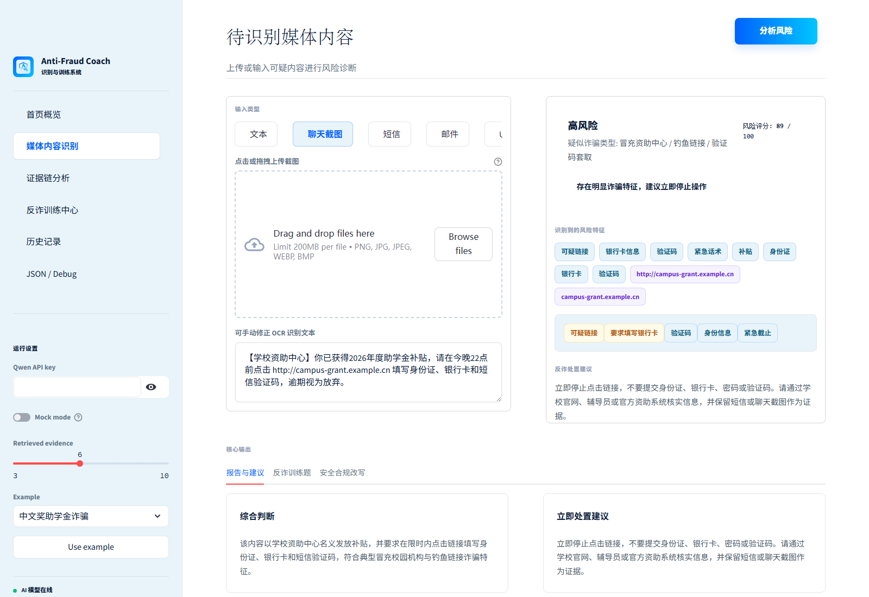
Figure 2. Streamlit runtime interface showing risk recognition, evidence tags, advice, and training-oriented output.
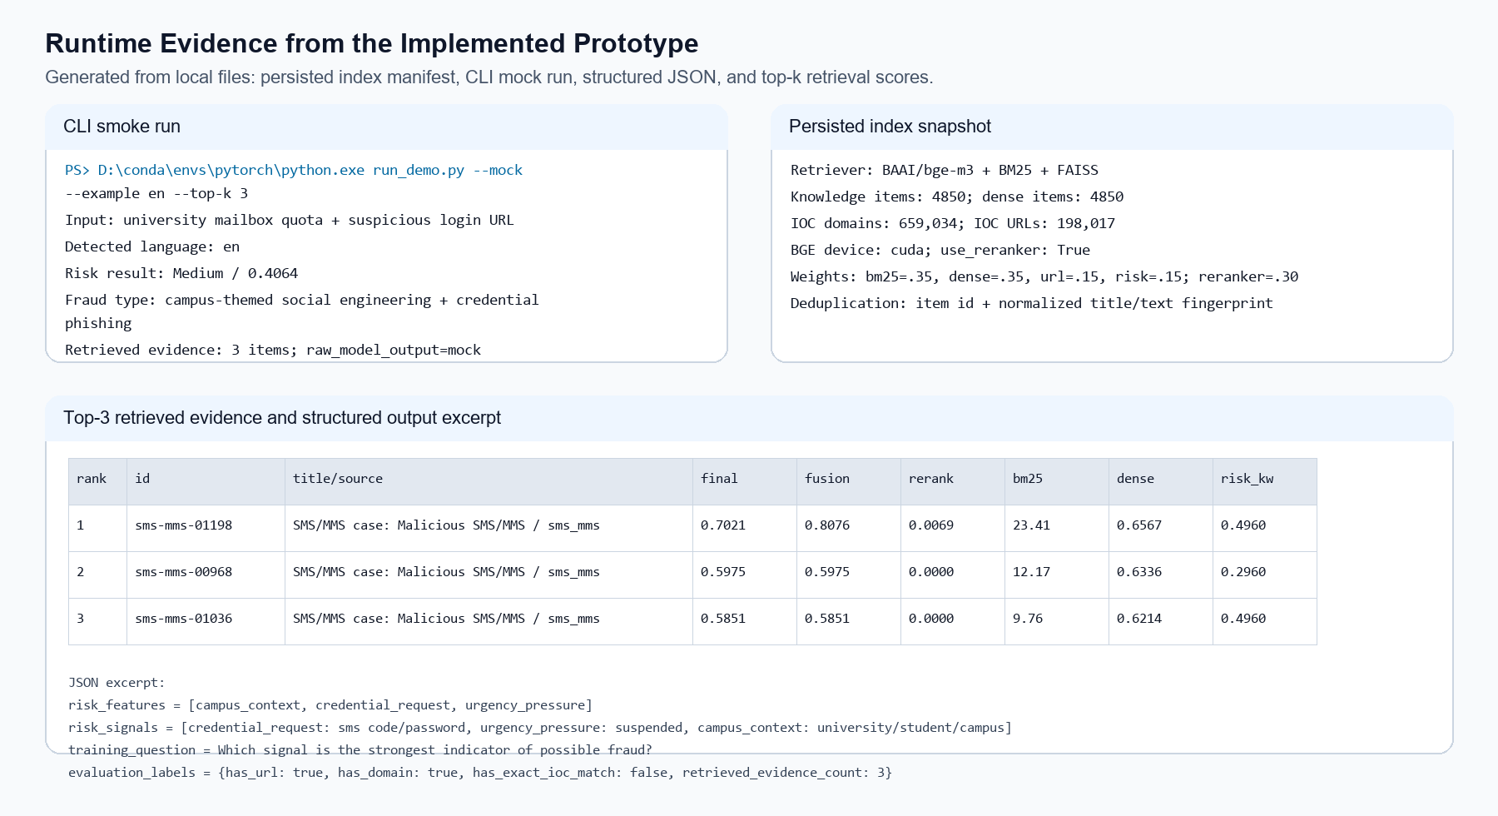
Figure 3. Runtime evidence excerpt generated from the CLI mock run, persisted index manifest, structured JSON, and top-k retrieval scores.

5. Evaluation Design and Preliminary Runtime Results

5.1 Evaluation Tasks
Evaluation focuses on risk classification, retrieval relevance, and structured JSON quality. In a six-case local mock smoke set (three fraud and three benign texts), Table 3 reports preliminary values. It is a sanity check for the implemented prototype, not a full held-out experiment. Risk-level thresholding treats Medium and High as fraud and Low as benign, matching the user-facing safety decision. The values are included to show that the system can produce measurable outputs and that later experiments can reuse the same schema, labels, and evidence fields. The figures are reported as smoke-test evidence, while final benchmarking should rebalance fraud types, separate blacklisted URLs, and include cross-language cases.
Table 3. Preliminary small-sample smoke-test results.
Metric | Preliminary value
Risk detection accuracy | 83.3% (5/6 mock cases)
Precision / recall / F1 | 1.00 / 0.67 / 0.80
JSON validity | 100% (6/6 valid structured outputs)
Required-field completion | 100% (6/6 include core schema fields)
Case Recall@5 proxy | 1/1 mailbox case retrieved relevant malicious evidence
Smoke-set size | 6 cases (3 fraud / 3 benign)
Core behavior tests | 14/14 passed

5.2 Retrieval Evaluation
Retrieval should be evaluated with BM25-only, dense-only, fusion, and fusion plus reranking, using Recall@K, MRR, NDCG@K, and manual relevance. The smoke run retrieves account-suspension evidence, but a larger held-out set is still required. Reporting both exact lexical and dense semantic variants is important because fraud messages may either reuse known phrases or describe the same risk with different wording.

5.3 Structured Output Evaluation
Structured output is measured by JSON validity, required-field completion, risk_level and fraud_type consistency, training_question success, and evidence_fusion availability. In the smoke set, all six mock outputs were valid JSON with required fields; larger measurement should repeat this over a balanced fraud/benign set. For the current report, these numbers mainly demonstrate that the implemented pipeline can be scored automatically instead of only inspected through screenshots.

5.4 Case Study: Mailbox-Credential Phishing Run
The CLI mock case uses the input: "Your university mailbox quota is full. Verify your student account now at http://secure-campus-login.example.com or your email access will be suspended. Enter your password and SMS code." The system extracted the URL/domain plus campus_context, credential_request, and urgency_pressure. It returned Medium risk (risk_score = 0.4064), fraud_type = Campus-themed social engineering + credential phishing/account takeover, and rank-1 evidence sms-mms-01198 with final_score = 0.7021. Same-input ablation: BM25-only -> sms-mms-01198, dense-only -> sms-mms-00331, fusion+rerank -> sms-mms-01198, preserving the most direct account-suspension evidence. This comparison explains why the final result is reasonable: BM25 anchors exact account and suspension terms, dense retrieval finds a semantically similar work-email suspension case, and fusion+rerank keeps the directly matching malicious SMS evidence at rank 1. Table 4 summarizes the output.
Table 4. Structured case-study output from the CLI mock run.
Output element | Observed value
Input type | English mailbox-quota message with suspicious login URL, password request, SMS-code request, and suspension pressure.
Extracted features | campus_context, credential_request, urgency_pressure; URL and domain detected.
Risk judgement | Medium risk; risk_score = 0.4064; fraud_type = campus-themed social engineering + credential phishing/account takeover.
Top evidence | Rank-1 evidence: sms-mms-01198, SMS/MMS case: Malicious SMS/MMS; final_score = 0.7021.
Evidence fusion | JSON reports final, fusion, reranker, BM25, dense, URL-match, and risk-keyword scores for each retrieved item.
Advice and training | Do not click unknown links or share credentials; training_question asks students to identify the strongest fraud signal.

6. Discussion and Conclusion

6.1 Advantages
The system has six main strengths: it supports Chinese-English bilingual and mixed-language text-media input, combines explicit risk features with RAG evidence, uses hybrid retrieval for recall, applies reranking for top-evidence precision, exposes structured JSON for evaluation, and turns recognition into quiz-style training-question generation. The design is therefore suitable for coursework demonstration of both safety analysis and learning-oriented feedback.

6.2 Limitations
The current prototype still has limitations. OCR quality can affect screenshot-derived text, and new scam scripts or domains can bypass existing rules and blacklists. LLM explanations still require schema and evidence constraints. Training is limited to generated quiz questions rather than an adaptive learning module, and larger held-out evaluation is needed before accuracy, retrieval relevance, or learning effect can be treated as established results.

6.3 Conclusion
This project builds an LLM-RAG text-media anti-fraud recognition system with training-question generation for college students. By integrating risk-feature extraction, hybrid retrieval, evidence fusion, BGE reranking, Qwen reasoning, and structured output, it offers an interpretable prototype that detects fraud risk, explains evidence, recommends safe actions, and generates educational questions. Future work should focus on balanced held-out evaluation, leakage-aware ablation, stronger multimodal preprocessing, indicator updates, and controlled learning studies.

References
[1] Chen, J., Xiao, S., Zhang, P., Luo, K., Lian, D., & Liu, Z. (2024). M3-Embedding: Multi-
linguality, multi-functionality, multi-granularity text embeddings through self-knowledge distillation. Findings of the Association for Computational Linguistics: ACL 2024, 2318-2335. https://arxiv.org/abs/2402.03216
[2] Douze, M., Guzhva, A., Deng, C., Johnson, J., Szilvasy, G., Mazare, P.-E., Lomeli, M., Hosseini, L., & Jegou, H. (2024). The Faiss library. arXiv. https://arxiv.org/abs/2401.08281
[3] Lewis, P., Perez, E., Piktus, A., Petroni, F., Karpukhin, V., Goyal, N., Kuttler, H., Lewis, M., Yih, W.-t., Rocktaschel, T., Riedel, S., & Kiela, D. (2020). Retrieval-augmented generation for knowledge-intensive NLP tasks. Advances in Neural Information Processing Systems, 33, 9459-9474. https://arxiv.org/abs/2005.11401
[4] Nogueira, R., & Cho, K. (2020). Passage re-ranking with BERT. arXiv. https://arxiv.org/abs/1901.04085
[5] Robertson, S., & Zaragoza, H. (2009). The probabilistic relevance framework: BM25 and beyond. Foundations and Trends in Information Retrieval, 3(4), 333-389. https://doi.org/10.1561/1500000019
[6] Timko, D., Hernandez Castillo, D., & Rahman, M. L. (2023). A quantitative study of SMS phishing detection. arXiv. https://arxiv.org/abs/2311.06911
[7] Campus Anti-Fraud Bilingual Rules. (2026). Campus anti-fraud bilingual rules [Data set]. Local coursework dataset.
[8] Tang, M., Zou, L., Liang, S. N., Jin, Z., Wang, W., & Cui, S. (2025). ChiFraud: A long-term web text benchmark for Chinese fraud detection [Data set]. GitHub. https://github.com/xuemingxxx/ChiFraud/tree/main/dataset
[9] notd5a. (n.d.). Malicious and benign SMS/MMS dataset [Data set]. Hugging Face. https://huggingface.co/datasets/notd5a/malicious-benign-sms-mms-dataset
[10] wangyuancheng. (n.d.). Discord scam / clean messages dataset [Data set]. Hugging Face. https://huggingface.co/datasets/wangyuancheng/discord-phishing-scam-clean
[11] weijianzhg. (n.d.). Email Safety Triage 10k [Data set]. Hugging Face. https://huggingface.co/datasets/weijianzhg/email-safety-triage-10k
[12] Phishing.Database Contributors. (2026). Phishing.Database [Data set]. GitHub. https://github.com/Phishing-Database/Phishing.Database
[13] PhishDestroy Team. (2024). PhishDestroy blocklist [Data set]. Hugging Face. https://huggingface.co/datasets/phishdestroy/destroylist
[14] ScamSniffer. (n.d.). ScamSniffer Web3 scam database [Data set]. GitHub. https://github.com/scamsniffer/scam-database
[15] Alibaba Cloud Model Studio. (2026). OpenAI-compatible Chat API for DashScope. https://www.alibabacloud.com/help/en/model-studio/compatibility-of-openai-with-dashscope

